Junior indoor archery championship

On Saturday 5th December two Bath Archers competed at the Junior indoor Archery Championships in Stoneleigh, near Coventry. Both girls shot a Portsmouth round, which is 60 arrows shot at a 60cm target at a distance of 20 yards. Altogether 275 of the countries finest young archers gathered together to compete in this tournament, alongside some of the countries top Olympians who were shooting a back to back round in the other end of the hall.

Bethany Ede contested the under 14 section coming a respectable 14th.

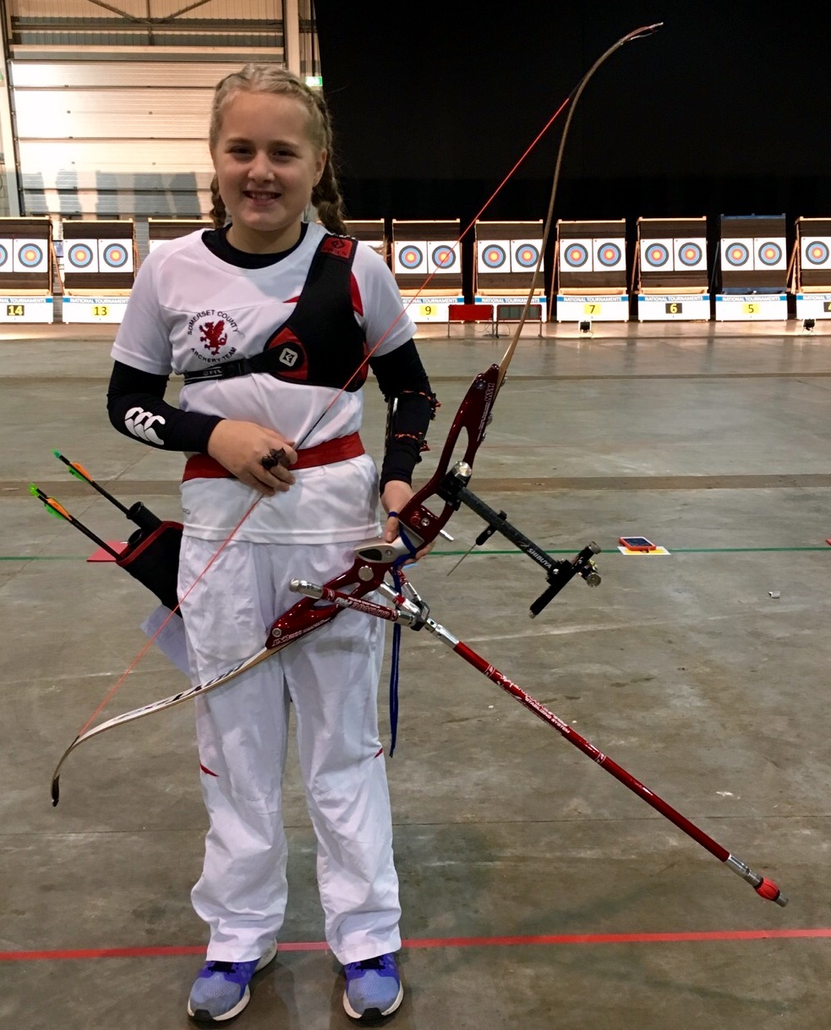

Also Jade Pocock, contested the under 16 section finishing a fantastic 7th place.

Jade was also picked to represent the England squad, to compete in the Junior Home Nations match. After a hard fought competition England were beaten into second position by Scotland by only one point. Jade is in action here and with the rest of the England squad.

